**Shifts in global fire regimes due to emerging trends in bioclimatic and human drivers**

Douglas I. Kelley1, *, Ioannis Bistinas2, Rhys Whitley3, Chantelle Burton4, Toby R. Marthews1, Ning Dong5,6

1: Centre for Ecology and Hydrology, Wallingford OX10 8BB, U.K.

2: Vrije Universiteit Amsterdam, Faculty of Sciences, Department of Earth Sciences, 1081 HV Amsterdam, The Netherlands

3: Natural Perils Pricing, Commercial and Consumer Portfolio and Product, Suncorp Group, Sydney, Australia

4: Met Office Hadley Centre for Climate Science and Services, Exeter, UK

5: Centre for Past Climate Change and School of Archaeology, Geography and Environmental Sciences (SAGES), University of Reading, Reading, United Kingdom

6: Department of Biological Sciences, Macquarie University, North Ryde, NSW 2109, Australia

* *Corresponding Author*

**Introductory paragraph**

The recent decline in fire occurrence in tropical savanna, attributed to increases in human suppression [1,2](https://paperpile.com/c/KGZtUN/oYYu+2XQx), has received a lot of attention due to its impact on trends in global burnt area [3](https://paperpile.com/c/KGZtUN/QeSr),[4,5](https://paperpile.com/c/KGZtUN/sYOD+CmxH). Large-scale trends in ecosystems where vegetation has adapted to infrequent fire, especially in cooler and wetter forested areas, are less well studied. Here, small changes in fire regimes can have a significant impact on local biogeochemistry [6](https://paperpile.com/c/KGZtUN/0CyK). In order to investigate trends in fire in these ecosystems, we used Bayesian inference [7](https://paperpile.com/c/KGZtUN/blPx) to quantify and map controls from four primary drivers: namely fuel continuity; fuel moisture; ignitions; and anthropogenic suppression. We found that fuel continuity and moisture are the dominant limiting factors of burnt area over most of the world. Suppression is most important in cropland areas, whereas fire in savannas and boreal forests is most sensitive to ignitions. We quantify fire regime shifts in areas with multiple, and often counteracting trends in these controls. Forests are of particular concern, where we show average shifts in controls of 32-36% of the potential maximum, mainly driven by trends in fuel continuity and moisture. This study gives added impetus to understand the impact of fire trends on ecosystem function and services.

**Main text**

Fire-prone tropical ecosystems account for 78% of global burnt area, despite covering just 16% of the land surface [8](https://paperpile.com/c/KGZtUN/OU7a). Changes in their fire regimes, therefore, have a disproportionate impact on trends in total global burnt area. Conversely, trends in non-fire prone ecosystems may not be easily detected in the global signal, and attributing changes in burnt area to only one driver is harder as bioclimatic controls also play a significant role in limiting fire [2,9,10](https://paperpile.com/c/KGZtUN/abh7+2XQx+fD52). To determine the drivers in these areas instead requires an assessment of the interplay of different controls on burnt area. Changes in such controls may also highlight potential shifts in fire regime not detectable via trend analysis of burnt area alone.

Coupled land surface-fire models are often used to assess changes in fire regime and associated feedbacks on local biogeochemistry [11–13](https://paperpile.com/c/KGZtUN/FFeS+ogEL+proI). However, most models fail to sufficiently reproduce recent trends in fire, and even disagree on basic spatial patterns or magnitudes of burnt area [1,2,14](https://paperpile.com/c/KGZtUN/2XQx+oYYu+VRj4) because of missing descriptions of key anthropogenic processes and/or an imbalance in the relative strength of bioclimatic controls [2,9,15](https://paperpile.com/c/KGZtUN/2XQx+abh7+l5be). Studies aimed at determining the relative strength of the control imposed by human and bioclimatic variables on burnt area could be exploited to isolate drivers of fire regime trends. Bistinas et al [15](https://paperpile.com/c/KGZtUN/l5be) used generalised linear modelling to explore the strength of controlling variables, highlighting direct causality from emergent patterns from controls that correlate but exert different influences on fire incidence. By selecting one key variable for each control, Kelley [8](https://paperpile.com/c/KGZtUN/OU7a) mapped relative limitations imposed by fapar, lightning and actual to potential evapotranspiration () for Australia. This was subsequently expanded globally and developed to incorporate multiple limiting variables into each of these three controls and by including a fourth control: human suppression [9](https://paperpile.com/c/KGZtUN/abh7).

Here, we assess trends in these burnt area controls in order to identify and quantify areas of fire regime change. We use variables that limit fire identified in [9,15](https://paperpile.com/c/KGZtUN/abh7+l5be) or heavily relied upon by the global fire modelling community [16](https://paperpile.com/c/KGZtUN/IWkT), which we split into four controls: fuel continuity (referred to as “fuel”); fuel moisture (“moisture”); potential natural and anthropogenic ignitions (“ignitions”); and anthropogenic suppression (“suppression”). Burnt area is constructed by multiplying the maximum permitted fire by each control (Fig. 1, methods equation 1-3) which, along with the contribution of each variable to their respective controls, is optimised against monthly observations of burnt area from GFED4s [17](https://paperpile.com/c/KGZtUN/jsqR) using an iterative Bayesian inference technique [7](https://paperpile.com/c/KGZtUN/blPx) between 2000-2014. This allows us to quantify the uncertainty of the resultant parameters and control contribution (see methods). Individual variables can be found in methods and Supplementary Fig. 1 and 2. Burned area constructed using this framework reproduces the magnitude and spatial pattern of annual burning and associated trends, with relatively little spread accounting for parameter uncertainty (Supplementary Table 1 and Supplementary Fig. 4).

Fuel limits burnt area at relatively high vegetative coverage (Fig. 1), allowing 50% monthly burning at 55% (± 0.01%) fuel continuity (where ± depends on parameter selection from our posterior distributions, see methods) which equates to roughly 87% of total vegetative cover (methods equation 3). Limitation only slowly increases with decreasing fuel, limiting monthly burnt area to 10% at fuel continuity of 27% (±0.52%), roughly 73% vegetation cover. Moisture content of 22% (±0.26%) limits fire incidence at 50%, with a sharp transition to 10% when moisture content increases to 29% (±0.15%) (Fig. 1), similar to studies of fuel moisture content levels that prohibit fire [18–20](https://paperpile.com/c/KGZtUN/N44L+r17a+7mG0). Ignitions have very little control on area burnt, with 50% burning allowed from 1.54 (±0.01) monthly ignition/km2 sources, below the amount of lightning found in areas not controlled by fuel (Supplementary Fig. 1). The impact of suppression increases rapidly at low cropland cover and/or population densities. Cropland is the major cause of fire suppression and limits burnt area by 50% at just 10.36 ± 0.12% cover (Supplementary Fig. 7). This suggests a significant landscape fragmentation impact beyond the extent of croplands. At global scales, population density above 288 ± 145 people/km2 reduces burnt area and suppresses fire by 50% (Supplementary Fig. 7). Low population densities only increase burning at specific times of the year in just a few areas (8.76 ± 6.96% of land cover) and always decrease burning when there is little other anthropogenic suppression.

To determine the relative limitations imposed by each control, we assessed the potential increase in fire if limitation by that control were removed, in the presence of the strength of the other three controls. We call this “potential limitation” (Fig. 2c,d; see methods equation 9). This is a more useful measure of determining potential for fire regime shift by a control than using the magnitude of the limiting factor in isolation of other controls, as in most limitation studies to date [8,9,21–23](https://paperpile.com/c/KGZtUN/hEWh+OzMh+abh7+OU7a+AZc4) (“standard limitation” Fig. 2a,b represented by the points along the curve in Fig. 1). Arid ecosystems have a significant “standard” limitation by ignitions due to little human impact or lightning. However, as there isn’t any fuel, the introduction of ignitions has no impact on burnt area. Conversely, increasing vegetation cover would lead to a small but, given the lack of current burning, significant increase in fire.

The difference between standard and potential limitation is even more important in boreal regions, where standard limitation misses the distinction between moisture limitation in Northern Europe, western Siberia and southern Canada, and more ignition limited areas in eastern Siberia, Alaska and Canadian tundra (Fig. 2). Globally, fuel and moisture impose the strongest controls on burnt area, limiting potential burnt area to 40% ± 2% and 59% ± 10% respectively of its otherwise unrestrained area. This is followed by suppression at 71% ± 13%, and ignitions which only limit burnt area to 79% ± 29%.

More relevant for potential short-term transient changes in burnt area is its rate of change given marginal change in a control in the presence of limitations imposed by all other controls (burnt area “sensitivity”, methods equation 10). During the fire season, burnt area in most tropical savanna ecosystems is unconstrained except occasionally by human suppression (Fig. 2c,d). However, these ecosystems show most sensitivity to combined changes in fire season ignitions and human suppression (Fig. 2e,f).

We attributed trends in burnt area over our study period to trends in these sensitivities by integrating the partial difference between reconstructed burnt area with and without the trends in each control (equation 11-12 in methods, Supplementary Fig. 6). This is normalised by mean monthly burnt area to determine the percentage of the maximum possible change in fire. Because of data availability, changes in lightning ignitions have not been incorporated. The recent rapid decline in tropical savanna and dry forest (see Supplementary Fig. 8 for biome definitions) burnt area is shown to be due to human suppression (Fig. 3c, 4) from increases in cropland cover and population density, although slightly offset by increases in ignitions from increased population (Supplementary Fig. 7). Suppression increases in tropical wet forests, particularly in Indonesia (Fig. 3) and in the southern end of the Amazon arc of deforestation, where changes in fire regime have already been attributed to a shift in agricultural practices from the liberative variable pasture to suppressive cropland [24](https://paperpile.com/c/KGZtUN/Rmky). Suppression decreases in Mediterranean and temperate areas (Fig. 4), namely in areas of reforestation and land use recession throughout North America and Europe (Supplementary Figs. 2, 7). Despite the attention the impact of suppression in tropical savanna has received [2](https://paperpile.com/c/KGZtUN/2XQx), trends in suppression actually have a much larger partial impact on burnt area in forested ecosystems (Table 1). In the whole though, fuel and moisture trends are much more important than direct human influence in most parts of the world (Table 1). Increases in vegetation cover decreases fuel limitation in arid and semi-arid ecosystems, affecting 75±2% of all Mediterranean and shrub/desert ecosystems and 63±6% of tropical savanna (Fig. 4). Changes in fuel limitation still have a significant impact in forest ecosystems, although normally less so than changes in moisture (Table 1). Drying conditions are causing a shift in the Kazakhstan/Russia fire zone, with Ural and Siberian boreal forests to the north becoming drier and more susceptible to fire, and more sparse vegetation cover reducing fire in Kazakhstan (Fig. 3c). Boreal and temperate forests in North America and central Europe show a change in moisture control of s similar magnitude that leads to lower fire incidence. In the Amazon, changes in moisture lead to both increases and decreases in fire depending on location. Decreases in moisture limitation in China's tropical and warm temperate forests is compounded by a retreat in cropland, both reducing suppression and increasing fuel availability (Fig. 3c).

With the exception of China, fuel and moisture trends are often anti-correlated in non-arid ecosystems, and there is a potential for a fire regime shift of greater magnitude than identified through changes in burnt area alone. As an index of regime shift, we measure the overall shift in controls potential limitation as a percentage of the maximum possible shift in controls (methods equation 13, Fig. 3b). Globally, there was a shift in fire controls of 26.88±0.35% during our study period - almost twice as high as the 14.23±0.48% trend in burnt area (Figure 4, Table 1). Despite the focus on fire contribution to the trend in global burnt area from tropical savanna [2](https://paperpile.com/c/KGZtUN/2XQx), forests are much more susceptible to a shift in fire regime, with an average shift in controls of - 33-34% for temperate and boreal forests and 32-36% for tropical forests. At least 10% of all ecosystems except the most arid show at least 50% of the maximum possible shift in controls.

Our optimized control framework reveals a number of interesting results that could help inform global fire model development. We show that suppression of burnt area by cropland is much greater than the croplands own extent, suggesting that landscape fragmentation is an additional mechanism of greater importance than homogenous cropland representation in any vegetation or Earth system models [16,25](https://paperpile.com/c/KGZtUN/IWkT+qWbv). Similarly, no models incorporate as dramatic a suppressive effect of population density as suggested to be necessary by this study [16](https://paperpile.com/c/KGZtUN/IWkT). Many recent global fire model development strands have focused on the correct representation of fuel and moisture controls [12,26,27](https://paperpile.com/c/KGZtUN/ogEL+fNLA+UdGO), arguing that ignitions are less important when reproducing global burnt area [8,9,15](https://paperpile.com/c/KGZtUN/OU7a+abh7+l5be). Our results partially support this hypothesis - areas of ignition limitation tend to occur in areas of even more severe fuel limitation, and 73% unburnt area can be explained through the representation of “potential” limitation imposed by fuel and moisture alone. However, we also show that many parts of the world are still sensitive to small changes in ignitions, particular savanna and boreal forests where levels of burning are important vegetative controls. Correct representation of ignitions is therefore still crucial for simulating and assessing transient fire regimes under changing climate, land use and population growth, and projected increases in lightning strikes [28](https://paperpile.com/c/KGZtUN/QANx). We were able to find these relationships using Bayesian Inference framework which could be extended to other areas of high uncertainty in land surface modelling, which we have made available for use (see methods for details).

We demonstrated that recent trends in fuel, moisture and suppression controls result in dramatic shifts in burnt area over much of the world. The overwhelming shift in fire regimes in forested biomes over our study period could have dramatic implications on Earth system feedbacks because of the amount of carbon they store. Our estimates are potentially conservative from excluding climate change impacts on natural ignitions sources - for which we show Boreal regions are sensitive too, and from a lack of El Niño years in our study period. A longer period would likely highlight more areas of robust fire regime shifts or shifts that persist over multiple decades. Modelling the impacts of fire on vegetation is largely unconstrained [25,29](https://paperpile.com/c/KGZtUN/TLyC+qWbv), and would also benefit from studies exploring fire-vegetation impacts at coarse global scales. This study could also be applied to determine how identified areas of fire regime change might evolve under future climate change, particularly when considering temperature targets set by the Paris agreement which, despite being loosely based on perceived widespread ecological and socio-economic thresholds, did not explicitly include changes in fire regime in their construction [30](https://paperpile.com/c/KGZtUN/CGDB).

**Acknowledgements**

The contribution by DK was supported by the UK Natural Environment Research Council through The UK Earth System Modelling Project (UKESM, Grant No. NE/N017951/1). ND was funded by European Research Council through Reading University (GC2.0 Grant No. 694481). CB’s contribution was supported by the Newton Fund through the Met Office Climate Science for Service Partnership Brazil (CSSP Brazil).

**Author Contributions**

DK and IB devised the modelling framework; RW designed the Bayesian inference framework; DK, IB and CB identified variables for use within the framework; DK, IB and TM designed the limitation and sensitivity assessments and fire regime shift index. DK performed trend analysis. DK, CB and ND collated and regridded input data; DK wrote the first draft of the paper with input from IB, CB and RW. All authors contributed to the final m/s.

The authors declare no competing interests.

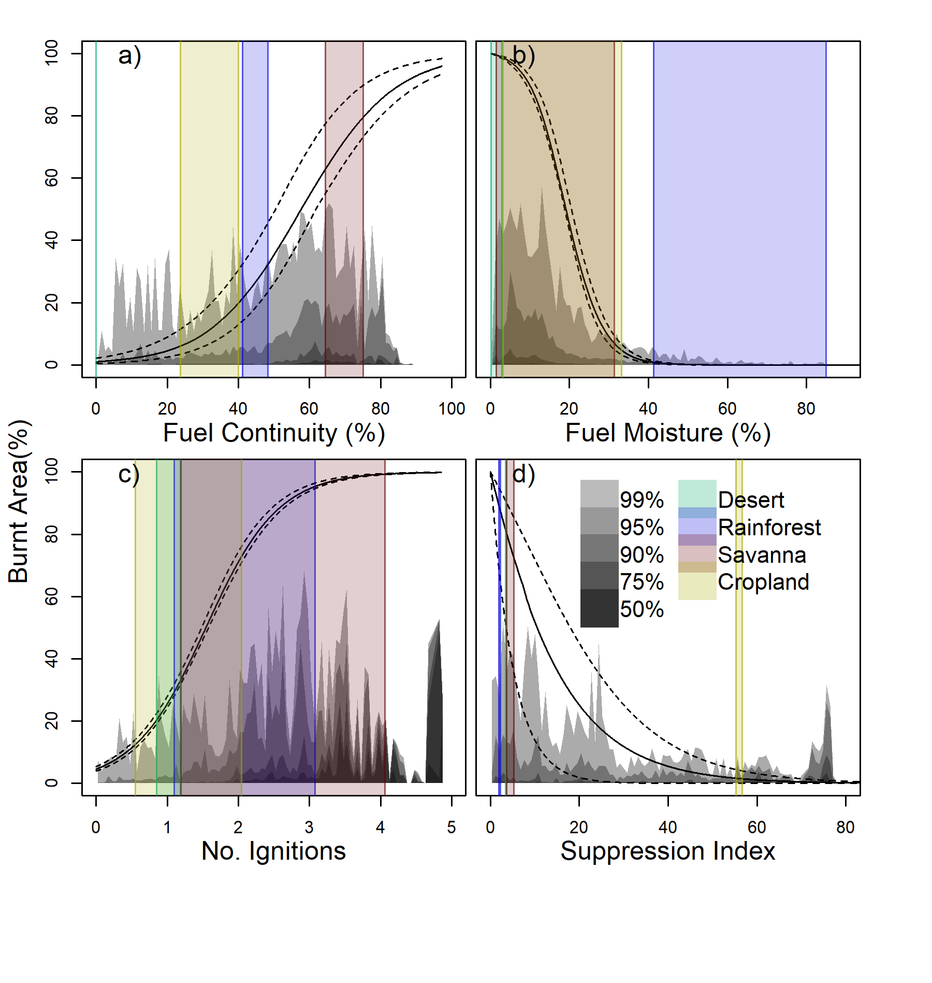

**Figure 1: Limitations imposed on burnt area by each control.** Controls describing a) fuel continuity; b) fuel moisture; c) potential ignitions; d) anthropogenic suppression were optimized against burnt area observations from GFED4s [17](https://paperpile.com/c/KGZtUN/jsqR). Solid black lines show optimized maximum possible burnt area for a given value of that control, using the median ensemble parameter values. Dotted lines show the interquartile range of our parameter ensemble members (see methods). Coloured areas show the limitation range over the time period of an example grid cell for (green) desert (blue) tropical wet rainforest (red) tropical savanna and (yellow) cropland areas, with geographic location shown in Fig. 2.

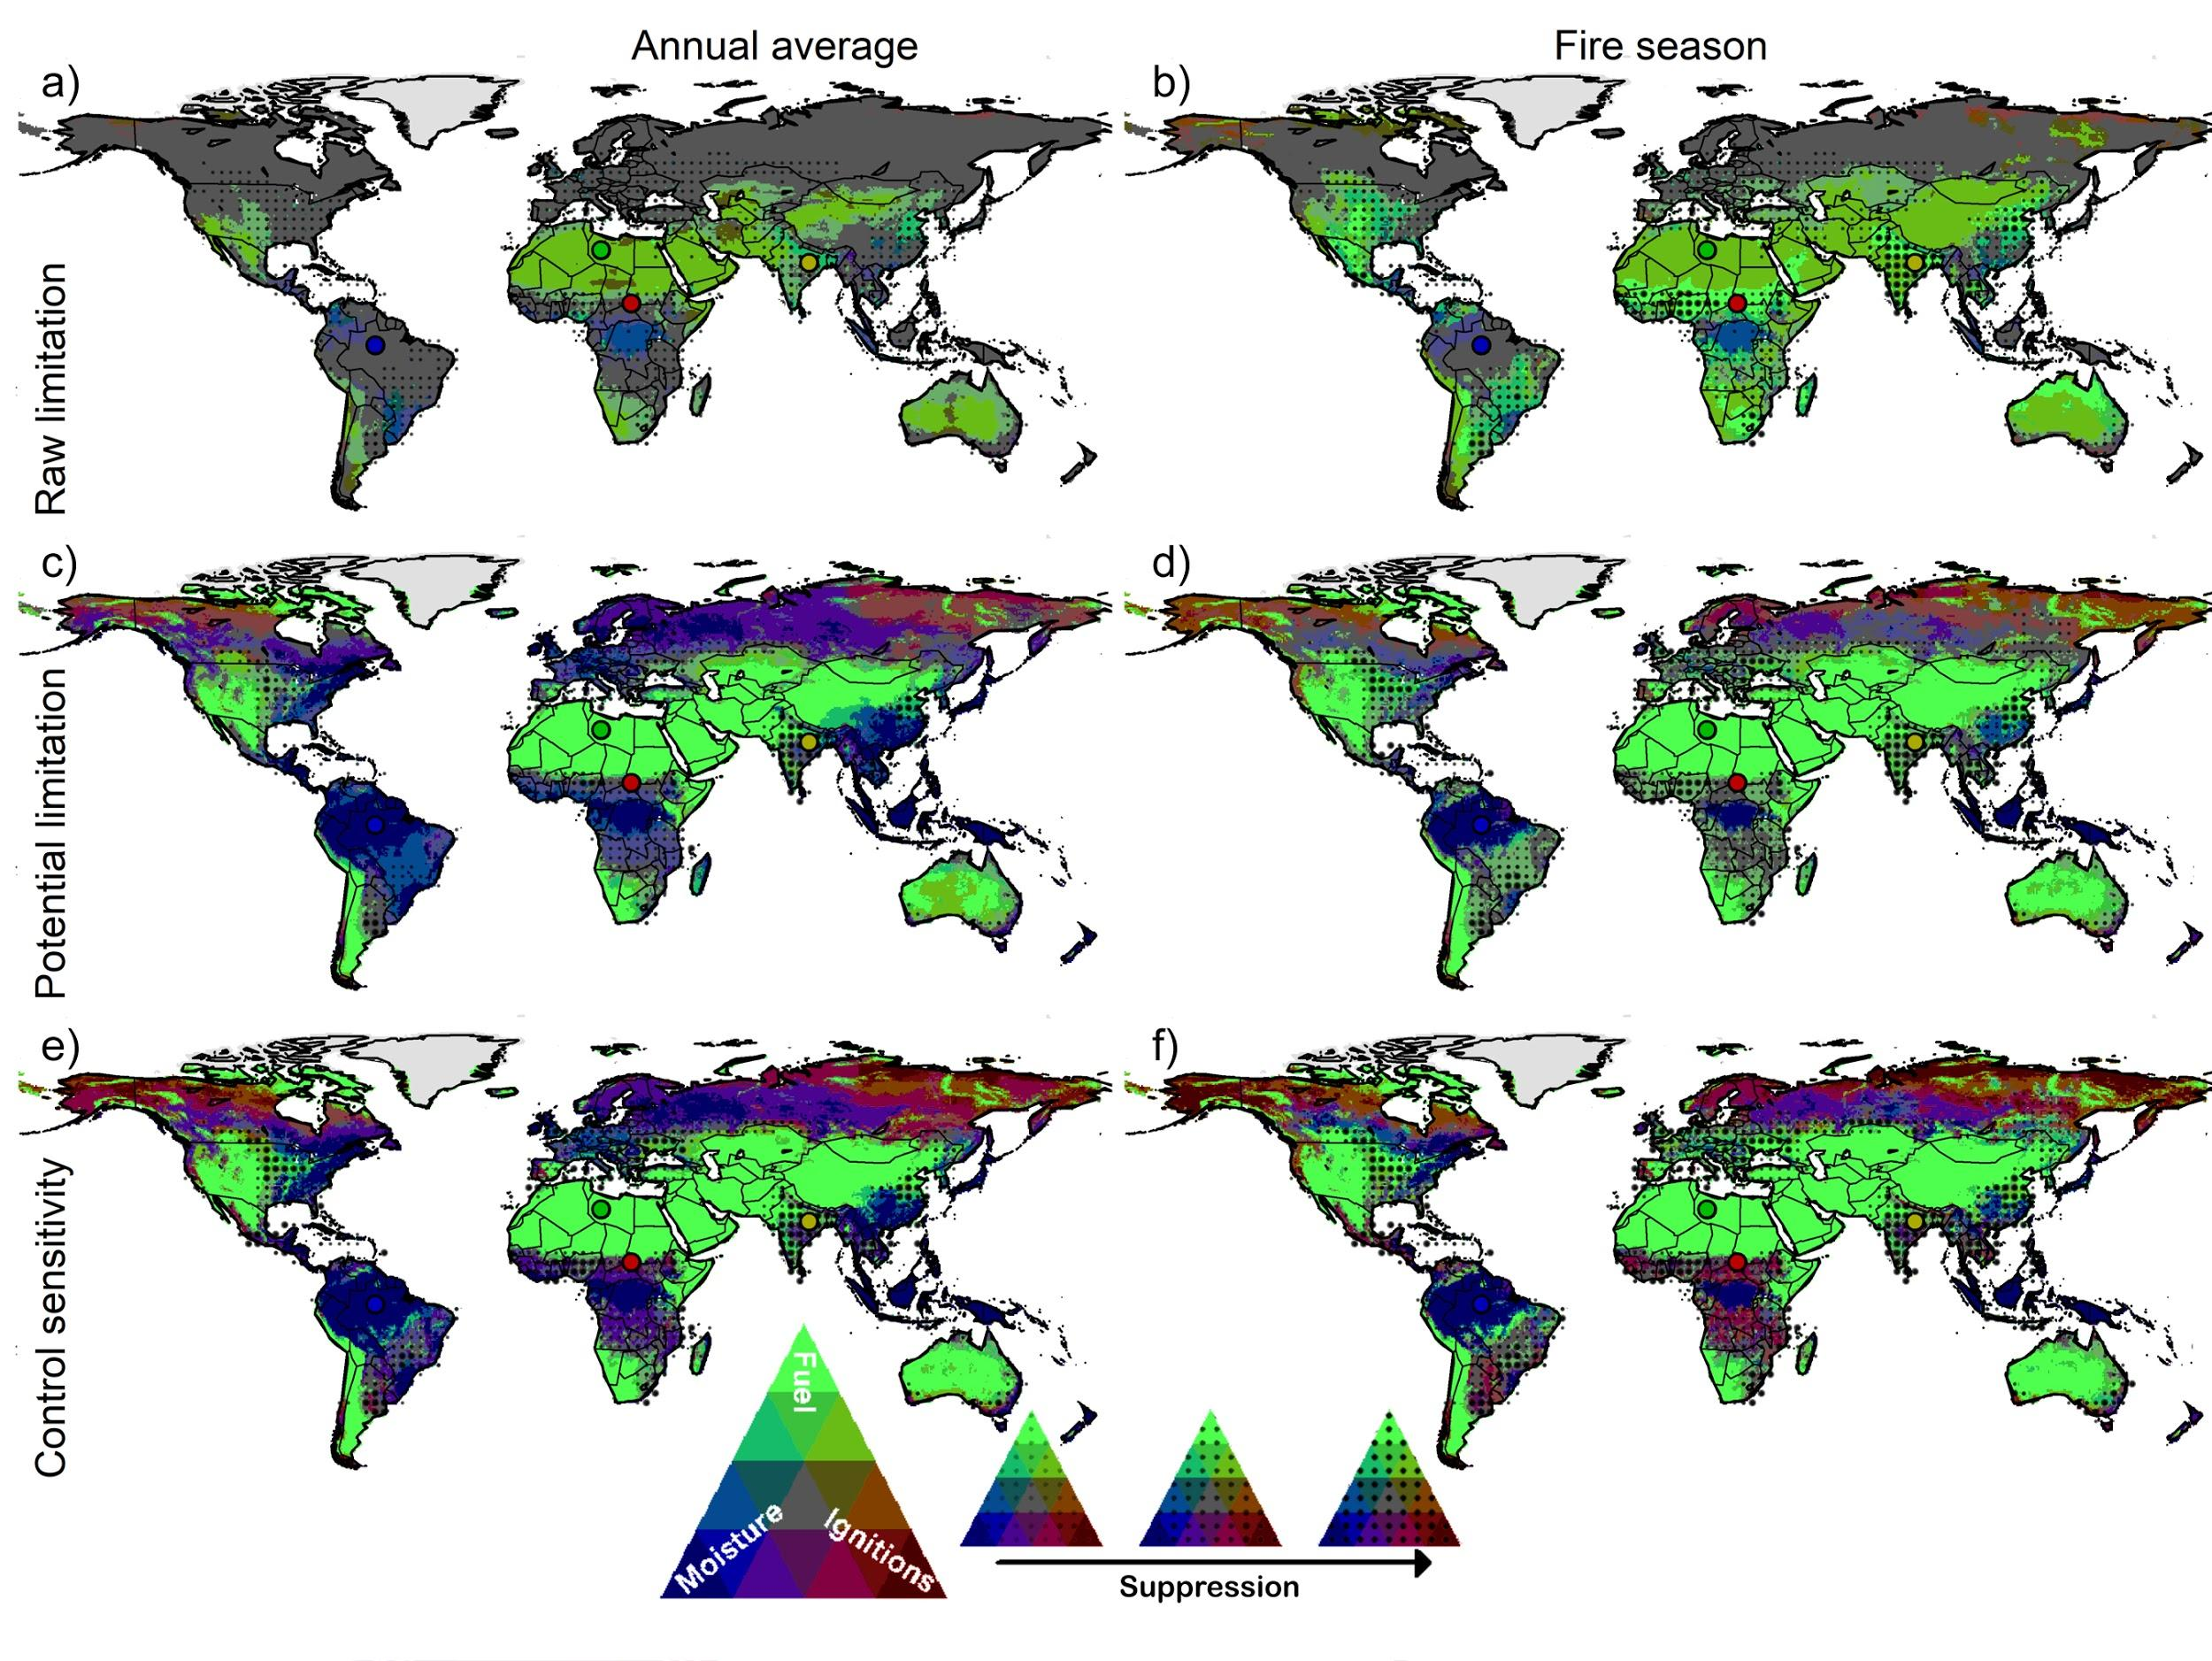

**Figure 2: Spatial variation of the relative limits imposed on burnt area by each control, normalised by the sum of all limitations from all four controls.** Green areas are predominantly fuel limited, blue are moisture limited, red by ignitions and hashed by suppression Combined shades demonstrate co-limitation: (cyan) fuel and moisture; (brown) moisture and ignitions and (magenta) moisture and ignitions. Grey areas are equally limited by all coloured variables. Standard limitation is limitation by each control in isolation of other controls (i.e, points on the curve in Fig. 1); potential limitation shows relative increases in burnt area if control is fully liberated in the presence of other controls; sensitivity is the change in burnt area from marginal changes in control in the presence over other controls. The 1st column shows the annual average limitations or sensitivity; the 2nd-row average limitation or sensitivity during the climatological month of the maximum burnt area. Green points show the location of “desert” in Fig. 1, blue show “rainforest”, red show “savanna” and yellow “cropland”.

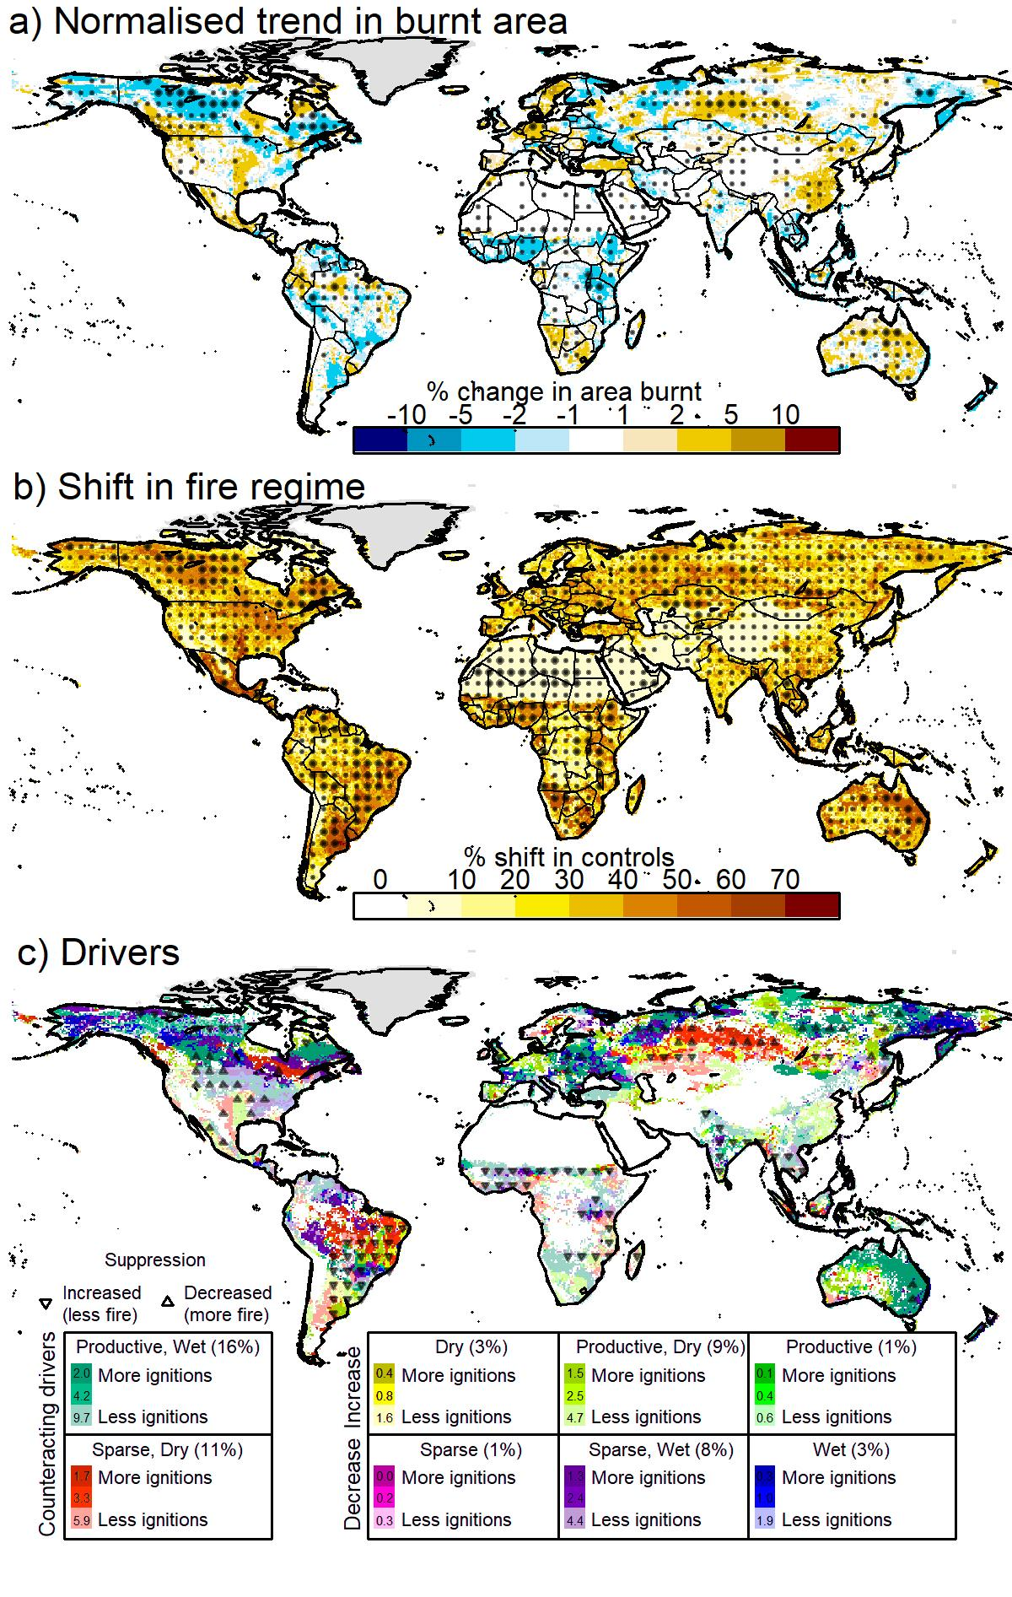

**Figure 3: Spatial trends in burnt area, and drivers of these trends.** a) Reconstructed trend in burnt area as a percentage of annual average burnt area for the period 2000-2014. Blue areas show decreases in burnt area, yellow/brown show increases. b) The combined impact of absolute changes in all trends as a percentage of the maximum possible shift, calculated using equation 13 in methods. Darker shades show areas of high combined trends in controls. Light hashed areas in a) and b) are where 90% of posterior parameter samples agree on the direction of change and heavy hashing shows where 99% agree. c) Areas with a shift of >50% in b, shaded by drivers of change when 90% of ensemble members agree and the direction of the driver. Increasing trends in burnt area caused by (dry - yellow) decreases in fuel moisture; (productive - green) increases fuel continuity ; (productive, dry - lime green) increased continuity and decreased moisture. Decreasing trends in (sparse - purple) decreases in fuel; (wet - blue) increases in moisture; (sparse, wet - violet) decreased fuel and increased in moisture. Counteraction drivers are (productive, wet - cyan) increased fuel and moisture; (sparse, dry - red) decreased fuel and moisture. Lighter colours show decreasing ignitions, darker show increasing. Downward arrows represent a decrease in burnt area from increases in suppression, upwards arrows represent increase in burnt area from decreased suppression. Percentages are given for land area covered by each fuel and moisture driver. Small number in legend colours indicate percent cover when considering increase, no change or decrease in ignitions.

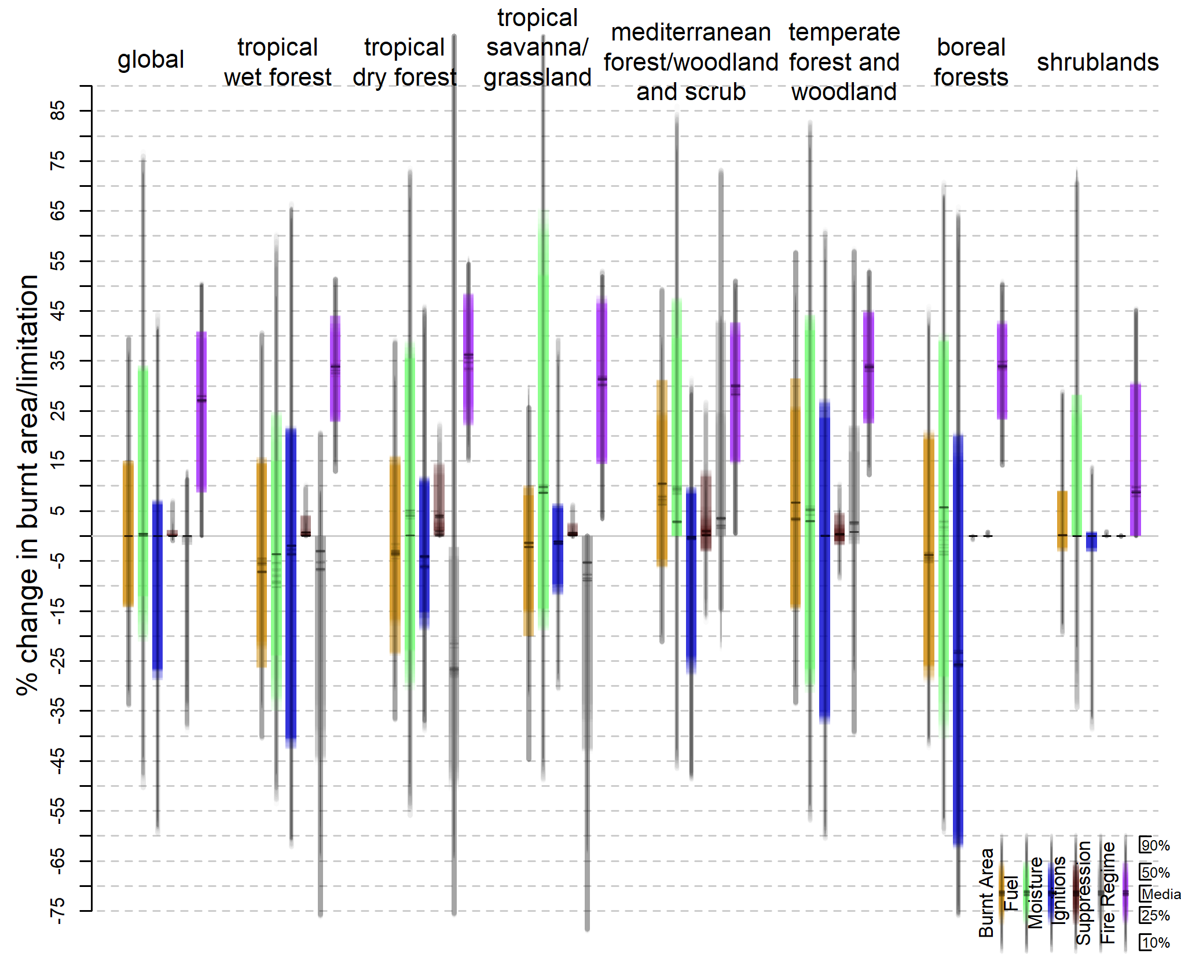

**Figure 4: Normalised trends in burnt area and controls on burnt area from 2000-2014 over.** The first block of 7 boxes is for globe trends, and subsequent boxes for each vegetation types as defined by [8](https://paperpile.com/c/KGZtUN/OU7a) (Supplementary Fig. 8). Horizontal lines show median, boxes show interquartile range and whiskers show 90% quantile for each of 100 randomly selected posterior parameter sets. (orange) the trend in burnt area as percentage of fraction of land area; (green) limitation imposed by fuel controls; (blue) by moisture controls; (brown) anthropogenic ignitions (grey) suppression; (purple) overall shift.

**Table 1: Impacts of trends in fire controls on burnt area between 2000-2014, globally and for each vegetation type**. The 1st row shows the mean absolute trend in burnt area (equation 12 in methods) as a percentage of mean burnt area, 2nd - 5th row changes in burnt area caused by trends in fuel, moisture, ignition and suppression controls. Remaining rows show the mean overall shifts in all controls and the shift for the 10%, 25% least affected areas covered by each vegetation type, median change, and 25% and 10% most affect areas covered by each vegetation type. Colour indicates the strength of the trend. See Supplementary Fig. 8 for biome areas. Top numbers in each box show mean across parameter ensembles, whilst bottom shows standard deviation across parameter ensemble members.

|  |  |  |  |  |  |  |  |  |  |
| --- | --- | --- | --- | --- | --- | --- | --- | --- | --- |
|  | | ***Global*** | ***Tropical***  ***wet forest*** | ***Tropical***  ***dry forest*** | ***Tropical***  ***savanna/grass*** | ***Med forest/***  ***woodland***  ***& Scrub*** | ***Temp***  ***forest &***  ***woodland*** | ***Boreal***  ***forests*** | ***Shrub/***  ***Desert*** |
| **Burnt Area** | | 14.23  0.48 | 20.17  1.08 | 17.34  1.75 | 12.94  0.60 | 17.29  2.01 | 20.69  1.54 | 24.23  0.93 | 4.17  0.22 |
| **Fuel** | | 25.30  2.15 | 24.82  4.69 | 30.63  2.45 | 33.92  1.87 | 23.71  2.74 | 34.33  1.54 | 35.89  1.42 | 6.87  0.71 |
| **Moisture** | | 14.18  0.62 | 34.21  0.55 | 15.01  1.28 | 8.93  0.74 | 16.93  1.01 | 30.71  1.08 | 48.38  1.53 | 0.67  0.13 |
| **Ignitions** | | 0.25  0.13 | 0.35  0.31 | 1.85  1.59 | 0.51  0.36 | 4.34  2.52 | 2.24  0.96 | 0.02  0.02 | 0.00  0.00 |
| **Suppression** | | 1.01  0.38 | 12.99  0.84 | 35.98  2.80 | 8.60  1.56 | 13.51  0.69 | 10.29  2.03 | 0.01  0.01 | 0.00  0.00 |
| **Fire Regime** | | 26.88  0.31 | 32.91  0.50 | 35.45  0.74 | 29.96  0.42 | 27.87  0.63 | 33.52  0.41 | 33.29  0.50 | 14.89  0.26 |
| ***Mean*** | |
| **Least affected**  **Most affected** | ***10%*** | 0.00  0.00 | 13.90  1.06 | 16.49  1.45 | 3.70  0.45 | 0.44  0.13 | 13.03  0.99 | 14.80  0.39 | 0.00  0.00 |
| ***25%*** | 10.98  0.63 | 23.19  0.64 | 23.68  1.54 | 14.67  0.52 | 14.39  0.40 | 22.78  0.57 | 24.12  0.54 | 0.00  0.00 |
| ***50%*** | 28.11  0.44 | 33.43  0.63 | 35.41  1.16 | 30.79  0.65 | 29.15  0.83 | 33.69  0.40 | 34.34  0.50 | 5.65  0.52 |
| ***75%*** | 41.24  0.75 | 42.57  1.32 | 47.20  1.35 | 46.07  0.93 | 41.41  1.19 | 44.55  0.51 | 42.46  0.56 | 27.87  0.50 |
| ***90%*** | 50.47  0.23 | 50.64  0.81 | 54.63  0.49 | 51.90  0.40 | 50.26  0.76 | 52.71  0.49 | 49.96  0.94 | 44.76  0.55 |

|  |  |  |  |  |  |  |  |  |
| --- | --- | --- | --- | --- | --- | --- | --- | --- |
| **Fire** |  |  |  |  |  |  |  |  |
| **Fuel** |  |  |  |  |  |  |  |  |
| **Moisture** | Least |  |  |  |  |  |  | Most |
| **Ignitions** | Impact |  |  |  |  |  |  | Impact |
| **Suppression** |  |  |  |  |  |  |  |  |

**Methods**

***Modelling framework***

Monthly burnt area () is calculated as a product of limitations imposed by four controls: fuel (dis)continuity () represented by vegetation cover, scaled by maximum 12-monthly plant available moisture ( - where is the ratio of actual to potential evapotranspiration); fuel moisture () represented by , fractional tree cover and atmospheric drying potential; ignition availability () represented by lightning strikes, population density and pasture cover; and direct human suppression () represented by cropland and population density (figure S1). Each control is expressed as a linear combination of their respective variables (see Supplementary Fig. 3 for weighting) and represented by a simple logistic curve (Fig. 1):

(1)

Where is the limitation imposed by control and is a maximum permitted monthly burnt area used to aid our model optimization. is the value of control when it imposes a limitation of 50% on burnt area (i.e,), and is the steepness of the logistic curve, equal to ¼ of the gradient at . for liberative controls and , where burnt area increases with the control, whereas for suppressive and , for which burnt area decreases. With the exception of , each control is represented by a combination of variables () weighted by their respective influence (). Where possible, units are consistent across variables within each control, and as such the combined variables are normalised to maintain these units:

and (2)

is represented by total fractional vegetation cover ()[31](https://paperpile.com/c/KGZtUN/nOgV). is only provided on an annual timestep. In order to capture the impact of seasonal variations of moisture on semi-arid ecosystem vegetation cover, we weight by the maximum anomaly over the previous 12 months (. Fractional cover was also raised to a power () in order to account for saturation for high coverage:

(3)

Where is an optimized weighting parameter.

is a combination of “live” fuel, dead fuel drying potential, and the impact of the canopy on atmospheric moisture content. Live fuel is represented by , calculated from CRUTS3.23 cloud cover, temperature and precipitation [32](https://paperpile.com/c/KGZtUN/mik9) using the STASH model [33](https://paperpile.com/c/KGZtUN/ojm9) (Supplementary Fig. 1). Dead fuel drying potential follows [27](https://paperpile.com/c/KGZtUN/UdGO) using CRU relative humidity, temperature, wet days and precipitation. MODIS Vegetation Continuous Fields (VCF) fractional tree cover [31](https://paperpile.com/c/KGZtUN/nOgV) is used as a proxy of canopy effects on moisture.

combines natural ignitions from climatological LIS/OTD lightning flash counts[34](https://paperpile.com/c/KGZtUN/waCj), with inter-cloud flashes removed using the technique described by [27](https://paperpile.com/c/KGZtUN/UdGO), and human-caused ignitions from HYDEv3.1 pasture cover and population density [35](https://paperpile.com/c/KGZtUN/8SfA).

combines HYDE population density and cropland [35](https://paperpile.com/c/KGZtUN/8SfA).

All variables were resampled to the coarsest (and most common) resolution of 0.5° using the r raster package [36](https://paperpile.com/c/KGZtUN/QNxX), with the exception of VCF, where tiles were merged and resampled to 0.5° using gdal [37](https://paperpile.com/c/KGZtUN/H1BB). Fractional cover and HYDE variables are interpolated from an annual to a monthly timestep. LIS lightning 12 month climatology was recycled each year. Equations 1 to 3 constitute our predictive burnt area model, with 17unknown parameters that are optimised using a form of heuristic search technique.

***Bayesian optimization***

We optimized our model framework against the GFED version 4 [3](https://paperpile.com/c/KGZtUN/QeSr) with small fires [38](https://paperpile.com/c/KGZtUN/TYmO) dataset (GFED4s) [17](https://paperpile.com/c/KGZtUN/jsqR) for the period 2000 to 2014 (the common years among all datasets) using Bayesian inference. In our case, Bayes theorem states that the likelihood of the values of our unexplained parameter set (i.e. all and in equation 1, in equation 2 and in equation 3), given a set of observations , is proportional to the prior probability distribution of () by the probability of give . i.e

(4)

We assume no prior knowledge of what values these parameters should have and set bounded uniform priors on all parameters, i.e bounds that are only physically plausible, but generously large [7](https://paperpile.com/c/KGZtUN/blPx). For the sake of simplicity, we define model error to be normally distributed:

(5)

where represents an individual data point, is the GFED4s burnt area observation, *σ* is the standard error, and *N* is the observation sample size. Given that our sample size is relatively large, our likelihood information dominates over the priors, such that the optimization reduces to a maximum likelihood problem. Consequently, inferring the Posterior solution is a case of minimising equation 5. We inferred the posterior solutions for each of the model parameters using a Metropolis-Hasting Markov chain Monte Carlo step, running 5 chains with 10,000 iterations using [39,40](https://paperpile.com/c/KGZtUN/CsYt+jEfD) each over 10% randomly sampled data points on a 0.5͒, monthly time step for 15 years; this represents a sample size of 2,314,512 data points. Unless otherwise stated, the analysis was conducted on a posterior solution constructed by sampling 100 parameter ensemble members from the last 5000 iterations of each chain. Final parameter values and distributions are shown in Supplementary Fig. 3.

***Framework assessment***

Our Bayesian inference model contains a framework error parameter which described the standard deviation of reconstructed fire from GFED4s observations. To help quantify the deviation between observations and each parameter combination, we normalise this term by GFED4s observed deviation. This is similar to the Normalised Mean Squared Error benchmarking method described in [41](https://paperpile.com/c/KGZtUN/YrKc8), but for each month rather than an annual average. As recommended by Fire Model Intercomparison Project (FireMIP) [16](https://paperpile.com/c/KGZtUN/IWkT), we also use the non-square metrics from [41](https://paperpile.com/c/KGZtUN/YrKc8) to assess each parameter combinations ability to reconstruct annual average burnt area and spatial trends in burnt area. The difference between reconstructed annual average burnt area from a given parameter set () and observed ( was assessed using the Normalised Mean Error () metric, which sums the difference over all cells () weighted by cell area () and normalises by the average distance from the mean of observations ():

(6)

NME comparisons are conducted in three steps:

1. As described above;
2. and are the difference between observations or simulation and their respective means. ie removing systematic bias and describe the performance of the model around the mean.
3. and from step 2 are divided by the mean deviation. i.e . This removes the influence of the variability and describes the models' ability to reproduce the spatial pattern in burnt area.

The trend in burnt area is calculated on a 12-month running mean to remove seasonal effects. As burnt area assumes values in the standard unit interval [0, 1], we first perform a logit transformation to assess trends relative to the current burnt area, taking into account maximum or minimum possible burnt area bounds. This removes model error in spatial patterns already assessed by equation 6 from our assessments of trends. Furthermore, as burnt area can take extremes of 0 and 1, we also perform an initial transformation so that bounds become (0, 1):

(7)

Where, in this case, is burnt area and is the number of timesteps, in this case, 168 months.

The burnt area trend is calculated for each grid cell using a simple linear regression model (8)

The difference in between observations and simulation are compared using (equation 6). Non-significant trends found in observations (i.e, p-value > 0.1) where not compared.

The smaller the score, the closer the simulation to observation, with a perfect score (i.e, simulation that perfectly matches observations) of 0. We use three null models to help interpret the score. The mean null model is the score obtained by comparing the mean of all observations with the observations. As is normalised by the mean difference, s mean null model score is always 1. The best “single value” model is obtained by comparing the median of observations to observations, and its score is by definition less than or equal to the mean model score for . We also compare randomly resampled observations (without replacement) to the observations. As this is different depending on resampling order, we perform 1000 bootstraps to describe three randomly resampled nulls models: the mean randomly resampled score and ± the standard deviation of our bootstrap. Randomly resampled bootstraps are almost always worse than the median and mean null models.

Our reconstructed annual average burnt area obtains an NME score of 0.60-0.63 vs GFED4s and 0.73-0.78 against other FireMIP benchmark datasets (Supplementary Table 1), which outperforms all null models, and is better than published assessment of other global vegetation-fire models using the same comparison method [14,25,41–43](https://paperpile.com/c/KGZtUN/YrKc8+qVJ2+qWbv+VRj4+zn2m), although most of these are driven by simulated vegetation and fuel. Similar scores for step 1 to 3 NME suggest our spatial pattern in burnt areas also performs well. Our spatial trend in burnt area score of 0.75-0.88 is also better than nulls models, beating the median null model by roughly the same percentage as our annual average scores.

***Standard, potential and sensitivity to limitation***

“Standard” limitation refers to the limitation imposed by each control under otherwise ideal burning conditions and is defined as (point along the curve in Fig. 1). “Potential” limitation ( for control is the potential increase in burnt area if the limitation imposed by a control is removed, in the presence of other controls:

(9)

Where is the product of all fire controls excluding the one being considered.

The sensitivity to limitation () is the change in burnt area () relative to the maximum rate of change in burnt area for that control (i.e when ), weighted by the potential limitation for that cell:

(10)

***Trend analysis***

Trends were calculated for burnt area by fitting a simple linear regression model as described in equation 8 for each month of the year over our time period. We also calculated trends for each control in the same way to assess its impact on burnt area. Because lightning ignition data was provided as a climatology, we only show the impact of population density on ignition trends. This trend was removed from each control, leaving behind just seasonal and interannual variability. The impact of the trend in control () is the reconstructed burnt area with the controls trend removed:

(11)

The difference between this and reconstructed fire including the trend (i.e in equation 1) was summed over our study period, and normalised between -100% and 100% to describe the maximum possible decrease or increase in burnt area due to trends in the control:

(12)

This also forms the basis of our measure of the overall shift in fire regime over our study period (). We quantify this overall change in our controls as the Euclidean distance between the potential impact of controls with and without detrending. This is similar to the square chord distance used in fire model evaluations to measure the difference between four items in two different datasets [16,41](https://paperpile.com/c/KGZtUN/YrKc8+IWkT) . Here, the difference in an “item” is the numerator in equation 12, equivalent to the difference in a control as a result of detrending, with each item weighted by the potential limitation (equation 9) in order to determine the change in it potential impact on burnt area of all controls. This is normalised by the maximum possible change in potential limitation (i.e, when the change in a given control over our study period is ±1) which is . As we have 4 controls, our change in fire regime is therefore determined by:

(13)

is equal to 0 if there is no change in controls, 1 if all controls change by the maximum possible, and ½ if one control changes by it’s maximum and with equal potential amongst all controls.

**Data availability**

The data that support the findings in this study are available from the corresponding author upon request.

**Code availability**

Our Bayesian framework is available for download and use. See [https://github.com/rhyswhitley/fire_limitation/](https://github.com/rhyswhitley/fire_limitation/tree/master) for more information.

**References**

1. [Knorr, W., Arneth, A. & Jiang, L. Demographic controls of future global fire risk. *Nat. Clim. Chang.* **6,** 781–785 (2016).](http://paperpile.com/b/KGZtUN/oYYu)

2. [Andela, N. *et al.* A human-driven decline in global burned area. *Science* **356,** 1356–1362 (2017).](http://paperpile.com/b/KGZtUN/2XQx)

3. [Giglio, L., Randerson, J. T. & van der Werf, G. R. Analysis of daily, monthly, and annual burned area using the fourth-generation global fire emissions database (GFED4). *Journal of Geophysical Research: Biogeosciences* **118,** 317–328 (2013).](http://paperpile.com/b/KGZtUN/QeSr)

4. [Marlon, J. R. *et al.* Climate and human influences on global biomass burning over the past two millennia. *Nat. Geosci.* **1,** 697–702 (2008).](http://paperpile.com/b/KGZtUN/sYOD)

5. [Arora, V. K. & Melton, J. R. Reduction in global area burned and wildfire emissions since 1930s enhances carbon uptake by land. *Nat. Commun.* **9,** 1326 (2018).](http://paperpile.com/b/KGZtUN/CmxH)

6. [Staal, A. *et al.* Resilience of tropical tree cover: The roles of climate, fire, and herbivory. *Glob. Chang. Biol.* (2018). doi:](http://paperpile.com/b/KGZtUN/0CyK)[10.1111/gcb.14408](http://dx.doi.org/10.1111/gcb.14408)

7. [Gelman, A. *et al.* *Bayesian Data Analysis, Third Edition*. (CRC Press, 2013).](http://paperpile.com/b/KGZtUN/blPx)

8. [Kelley, D. I. Modelling Australian fire regimes. (Macquarie University, 2014).](http://paperpile.com/b/KGZtUN/OU7a)

9. [Forkel, M. *et al.* A data-driven approach to identify controls on global fire activity from satellite and climate observations (SOFIA V1). *Geoscientific Model Development* **10,** 4443–4476 (2017).](http://paperpile.com/b/KGZtUN/abh7)

10. [Abatzoglou, J. T., Williams, A. P., Boschetti, L., Zubkova, M. & Kolden, C. A. Global patterns of interannual climate-fire relationships. *Glob. Chang. Biol.* (2018). doi:](http://paperpile.com/b/KGZtUN/fD52)[10.1111/gcb.14405](http://dx.doi.org/10.1111/gcb.14405)

11. [Kelley, D. I. & Harrison, S. P. Enhanced Australian carbon sink despite increased wildfire during the 21st century. *Environ. Res. Lett.* **9,** 104015 (2014).](http://paperpile.com/b/KGZtUN/FFeS)

12. [Prentice, I. C. *et al.* Modeling fire and the terrestrial carbon balance. *Global Biogeochem. Cycles* **25,** (2011).](http://paperpile.com/b/KGZtUN/ogEL)

13. [Lasslop, G., Brovkin, V., Reick, C. H., Bathiany, S. & Kloster, S. Multiple stable states of tree cover in a global land surface model due to a fire-vegetation feedback. *Geophys. Res. Lett.* **43,** 6324–6331 (2016).](http://paperpile.com/b/KGZtUN/proI)

14. [Kloster, S. & Lasslop, G. Historical and future fire occurrence (1850 to 2100) simulated in CMIP5 Earth System Models. *Glob. Planet. Change* **150,** 58–69 (2017).](http://paperpile.com/b/KGZtUN/VRj4)

15. [Bistinas, I., Harrison, S. P., Prentice, I. C. & Pereira, J. M. C. Causal relationships versus emergent patterns in the global controls of fire frequency. *Biogeosciences* **11,** 5087–5101 (2014).](http://paperpile.com/b/KGZtUN/l5be)

16. [Rabin, S. S. *et al.* The Fire Modeling Intercomparison Project (FireMIP), phase 1: Experimental and analytical protocols. *Geoscientific Model Development* **10,** 1175 (2017).](http://paperpile.com/b/KGZtUN/IWkT)

17. [van der Werf, G. R. *et al.* Global fire emissions estimates during 1997–2016. *Earth System Science Data* **9,** 697–720 (2017).](http://paperpile.com/b/KGZtUN/jsqR)

18. [Brown, J. K., Intermountain Forest and Range Experiment Station (Ogden & Utah). *Field test of a rate-of-fire-spread model in slash fuels /*. (1972).](http://paperpile.com/b/KGZtUN/N44L)

19. [Blackmarr, W. H. *Moisture Content Influences Ignitability of Slash Pine Litter*. (1972).](http://paperpile.com/b/KGZtUN/r17a)

20. [Danson, F. M. & Bowyer, P. Estimating live fuel moisture content from remotely sensed reflectance. *Remote Sens. Environ.* **92,** 309–321 (2004).](http://paperpile.com/b/KGZtUN/7mG0)

21. [Nemani, R. R. *et al.* Climate-driven increases in global terrestrial net primary production from 1982 to 1999. *Science* **300,** 1560–1563 (2003).](http://paperpile.com/b/KGZtUN/hEWh)

22. [Jolly, W. M., Nemani, R. & Running, S. W. A generalized, bioclimatic index to predict foliar phenology in response to climate. *Glob. Chang. Biol.* **11,** 619–632 (2005).](http://paperpile.com/b/KGZtUN/OzMh)

23. [Churkina, G. & Running, S. W. Contrasting Climatic Controls on the Estimated Productivity of Global Terrestrial Biomes. *Ecosystems* **1,** 206–215 (1998).](http://paperpile.com/b/KGZtUN/AZc4)

24. [Lapola, D. M. *et al.* Pervasive transition of the Brazilian land-use system. *Nat. Clim. Chang.* **4,** 27–35 (2014).](http://paperpile.com/b/KGZtUN/Rmky)

25. [Hantson, S. *et al.* The Status and Challenge of Global Fire Modelling. *Biogeosciences* **13,** 3359–3375 (2016).](http://paperpile.com/b/KGZtUN/qWbv)

26. [Knorr, W., Kaminski, T., Arneth, A. & Weber, U. Impact of human population density on fire frequency at the global scale. *Biogeosciences* **11,** 1085–1102 (2014).](http://paperpile.com/b/KGZtUN/fNLA)

27. [Kelley, D. I., Harrison, S. P. & Prentice, I. C. Improved simulation of fire–vegetation interactions in the Land surface Processes and eXchanges dynamic global vegetation model (LPX-Mv1). *Geoscientific Model Development* **7,** 2411–2433 (2014).](http://paperpile.com/b/KGZtUN/UdGO)

28. [Romps, D. M., Seeley, J. T., Vollaro, D. & Molinari, J. Climate change. Projected increase in lightning strikes in the United States due to global warming. *Science* **346,** 851–854 (2014).](http://paperpile.com/b/KGZtUN/QANx)

29. [Ciais, P. *et al.* Carbon and other biogeochemical cycles. in *Climate change 2013: the physical science basis. Contribution of Working Group I to the Fifth Assessment Report of the Intergovernmental Panel on Climate Change* 465–570 (Cambridge University Press, 2014).](http://paperpile.com/b/KGZtUN/TLyC)

30. [Knutti, R., Rogelj, J., Sedláček, J. & Fischer, E. M. A scientific critique of the two-degree climate change target. *Nat. Geosci.* **9,** 13–18 (2015).](http://paperpile.com/b/KGZtUN/CGDB)

**References appearing only in methods**

31. [Dimiceli, C. *et al.* MOD44B MODIS/Terra Vegetation Continuous Fields Yearly L3 Global 250m SIN Grid V006. (2015). doi:](http://paperpile.com/b/KGZtUN/nOgV)[10.5067/MODIS/MOD44B.006](http://dx.doi.org/10.5067/MODIS/MOD44B.006)

32. [Harris, I., Jones, P. D., Osborn, T. J. & Lister, D. H. Updated high-resolution grids of monthly climatic observations - the CRU TS3.10 Dataset. *Int. J. Climatol.* **34,** 623–642 (2013).](http://paperpile.com/b/KGZtUN/mik9)

33. [Davis, T. W. *et al.* Simple process-led algorithms for simulating habitats (SPLASH v.1.0): robust indices of radiation, evapotranspiration and plant-available moisture. *Geoscientific Model Development* **10,** 689–708 (2017).](http://paperpile.com/b/KGZtUN/ojm9)

34. [Cecil, D. J., Buechler, D. E. & Blakeslee, R. J. Gridded lightning climatology from TRMM-LIS and OTD: Dataset description. *Atmos. Res.* **135-136,** 404–414 (2014).](http://paperpile.com/b/KGZtUN/waCj)

35. [Klein Goldewijk, K., Goldewijk, K. K., Beusen, A., Van Drecht, G. & De Vos, M. The HYDE 3.1 spatially explicit database of human-induced global land-use change over the past 12,000 years. *Glob. Ecol. Biogeogr.* **20,** 73–86 (2010).](http://paperpile.com/b/KGZtUN/8SfA)

36. [Hijmans, R. J. & van Etten, J. raster: Geographic data analysis and modeling. *R package version* **2,** (2014).](http://paperpile.com/b/KGZtUN/QNxX)

37. [GDAL/OGR contributors. *GDAL/OGR Geospatial Data Abstraction software Library*. (Open Source Geospatial Foundation, 2018).](http://paperpile.com/b/KGZtUN/H1BB)

38. [Randerson, J. T., Chen, Y., van der Werf, G. R., Rogers, B. M. & Morton, D. C. Global burned area and biomass burning emissions from small fires. *Journal of Geophysical Research: Biogeosciences* **117,** (2012).](http://paperpile.com/b/KGZtUN/TYmO)

39. [Salvatier, J., Wiecki, T. V. & Fonnesbeck, C. Probabilistic programming in Python using PyMC3. *PeerJ Comput. Sci.* **2,** e55 (2016).](http://paperpile.com/b/KGZtUN/CsYt)

40. [Al-Rfou, R. *et al.* Theano: A Python framework for fast computation of mathematical expressions. *arXiv preprint* (2016).](http://paperpile.com/b/KGZtUN/jEfD)

41. [Kelley, D. I. *et al.* A comprehensive benchmarking system for evaluating global vegetation models. *Biogeosciences* **10,** 3313–3340 (2013).](http://paperpile.com/b/KGZtUN/YrKc8)

42. [Lasslop, G., Thonicke, K. & Kloster, S. SPITFIRE within the MPI Earth system model: Model development and evaluation. *Journal of Advances in Modeling Earth Systems* **6,** 740–755 (2014).](http://paperpile.com/b/KGZtUN/qVJ2)

43. [Burton, C. *et al.* Representation of disturbance in the Joint UK Land Environment Simulator Vn4.8 (JULES). *Geoscientific Model Development Discussions* 1–23 (2018).](http://paperpile.com/b/KGZtUN/zn2m)